**Lab 4**

* **Example 4:**
* **Source code:**

#include <stdio.h>

int main()

{

int num1;

printf ("Enter value =\n");

scanf ("%d",&num1);

if(num1>0)

printf("num1 = %d is positive\n",num1);

else if (num1<0)

printf("num1 = %d is negative ",num1);

else

printf("num1 = %d is zero ",num1);

return 0;

}

* **Output:**

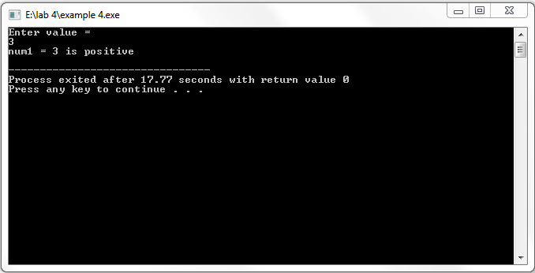

* **Example 5:**
* **Source code:**

#include <stdio.h>

int main()

{

int day;

printf("Enter a number (1-7) to get the corresding day of the week: ");

scanf("%d", &day);

switch (day){

case 1:

printf("Monday\n");

break;

case 2:

printf("Tuesday\n");

break;

case 3:

printf("Wednesday\n");

break;

case 4:

printf("Thursday\n");

break;

case 5:

printf("Friday\n");

break;

case 6:

printf("Saturday\n");

break;

case 7:

printf("Sunday\n");

break;

default:

printf("Invalid input! Please enter a number between 1 and 7.\n");

}

return 0;

}

* **Output:**

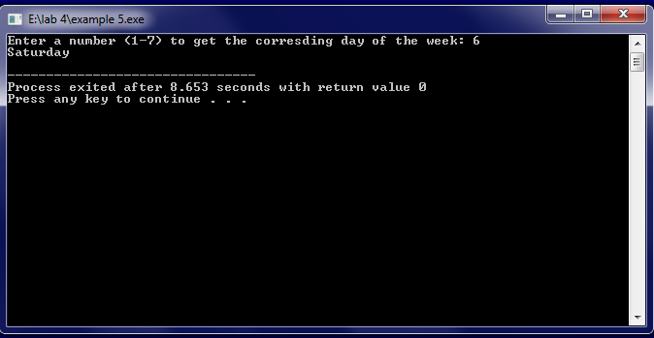

* **Question 1:**
* **Source code:**

#include <stdio.h>

int main()

{

int num;

printf("Enter a number: ");

scanf("%d", &num);

if(num%3==0)

printf("It is a multiple of 3");

else

printf("It is not a multiple of 3");

}

* **Output:**

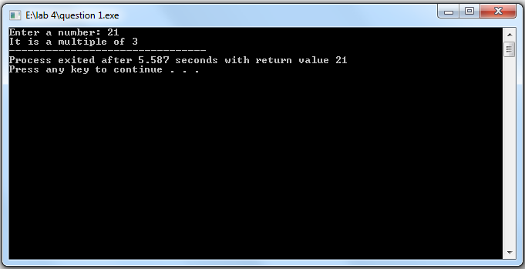

* **Question 2:**
* **Source code:**

#include <stdio.h>

int main()

{

int num1,num2,z;

char op;

printf("Enter a number (operand1): ");

scanf("%d", &num1);

printf("Enter a number (operand2): ");

scanf("%d", &num2);

printf("Enter an operator (+ or – or * or /): ");

scanf(" %c", &op);

switch (op){

case '+':

printf("Resultant of addition is: %d\n", num1+num2);

break;

case '-':

printf("Resultant of subtraction is: %d\n", num1-num2);

break;

case '*':

printf("Resultant of multiplication is: %d\n", num1*num2);

break;

case '/':

printf("Resultant of division is: %d\n", num1/num2);

break;

default:

printf("Invalid input!");

}

return 0;

}

* **Output:**

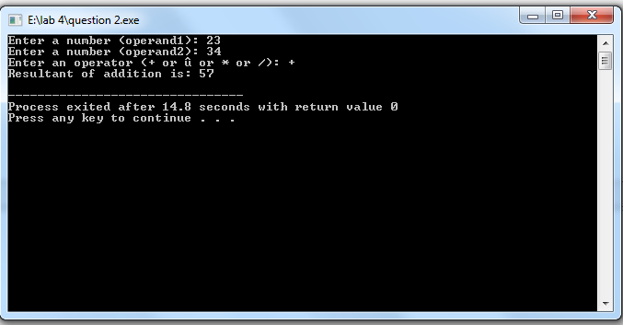

* **Question 3:**
* **Source code:**

#include <stdio.h>

int main()

{

char a;

printf("Enter a lowercase character/uppercase character/number/special character ");

scanf("%c", &a);

if ((a>=65)&&(a<=90))

printf("This is a uppercase character");

else if((a>=97)&&(a<=122))

printf("This is an lowercase character");

else if((a>=48)&&(a<=57))

printf("This is a digit");

else

printf("This is a special character");

}

* **Output:**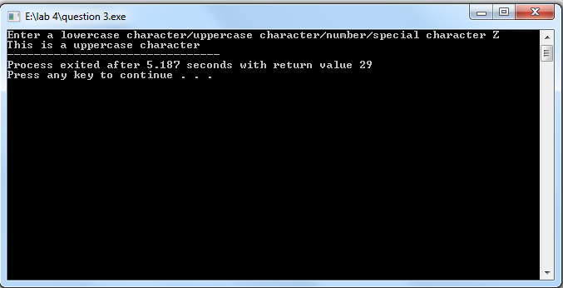
* **Question 4:**
* **Source code:**

#include <stdio.h>

int main()

{

int cost;

float d,total;

printf("Enter cost of shopping: ");

scanf("%d",&cost);

if (cost<500)

printf("No discount");

else if (cost<2000)

{

d = cost*5/100;

total = cost-d;

printf("Actual amount was: %d, \nSaved amount is: %f, \nAmount after discount is: %f", cost,d,total);

}

else if ((cost>=2000)&&(cost<=4000))

{

d = cost*10/100;

total = cost-d;

printf("Actual amount was: %d, \nSaved amount is: %f, \nAmount after discount is: %f", cost,d,total);

}

else if ((cost>4000)&&(cost<=6000))

{

d = cost*20/100;

total = cost-d;

printf("Actual amount was: %d, \nSaved amount is: %f, \nAmount after discount is: %f", cost,d,total);

}

else

{

d = cost*35/100;

total = cost-d;

printf("Actual amount was: %d, \nSaved amount is: %f, \nAmount after discount is: %f", cost,d,total);

}

}

* **Output:**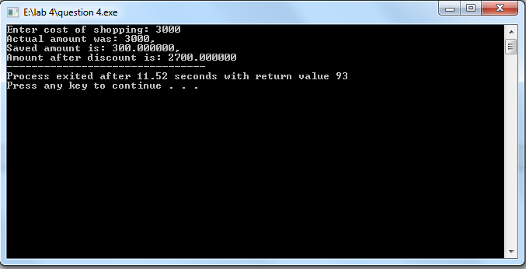
* **Question 5:**
* **Source code:**

#include <stdio.h>

int main()

{

int cid,units;

float bill;

char name;

printf("Enter customer ID:");

scanf("%d", &cid);

printf("Enter customer Name:");

scanf(" %c", &name);

printf("Enter units consumed:");

scanf("%d", &units);

if (units<=199)

{

bill = units*16.2;

printf("Your amount charges is: %f",bill);

}

else if ((units>=200)&&(units<300))

{

bill = units*20.1;

printf("Your amount charges is: %f",bill);

}

else if ((units>=300)&&(units<500))

{

bill = units*27.1;

printf("Your amount charges is: %f",bill);

}

else

{

bill = units * 35.9;

printf("Your amount charges is: %f",bill);

}

if(bill>18000)

{

int sc = bill*15/100;

printf("\nSurcharge charges is: %d",sc);

printf("\nYour total bill is: %f",bill+sc);

}

}

* **Output:  
  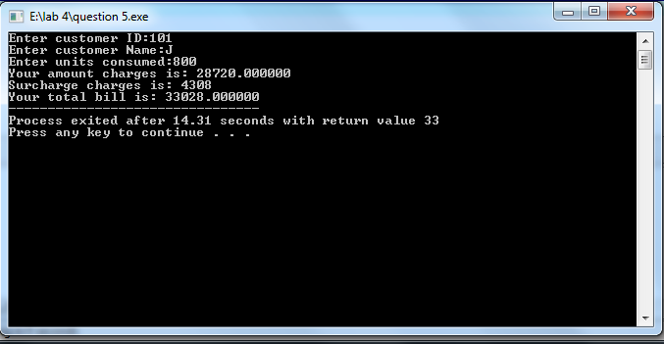**
* **Question 6:**
* **Source code:**

#include <stdio.h>

int main()

{

int n;

printf("Enter a number: ");

scanf("%d",&n);

if ((n>=1)&&(n<=9))

{

if(n==1)

printf("one");

else if(n==2)

printf("two");

else if(n==3)

printf("three");

else if(n==4)

printf("four");

else if(n==5)

printf("five");

else if(n==6)

printf("six");

else if(n==7)

printf("seven");

else if(n==8)

printf("eight");

else if(n==9)

printf("nine");

}

else if(n>9)

printf("greater than nine");

}

* **Output:**

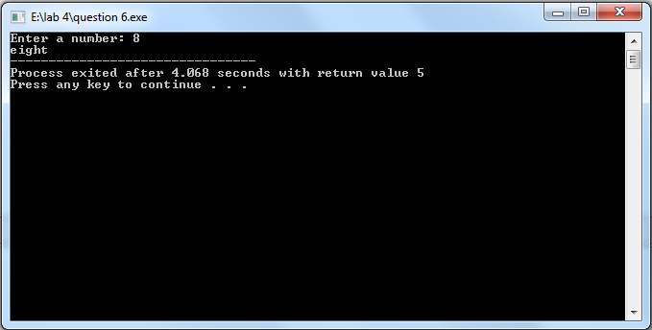

* **Question 7:**
* **Source code:**

#include <stdio.h>

int main()

{

int li;

printf("Enter value of light sensor");

scanf("%d",&li);

if ((li>=0)&&(li<=100))

printf("Evening");

else if ((li>100)&&(li<=500))

printf("Lightning");

else

printf("Exposed under sunshine");

* **Output:**

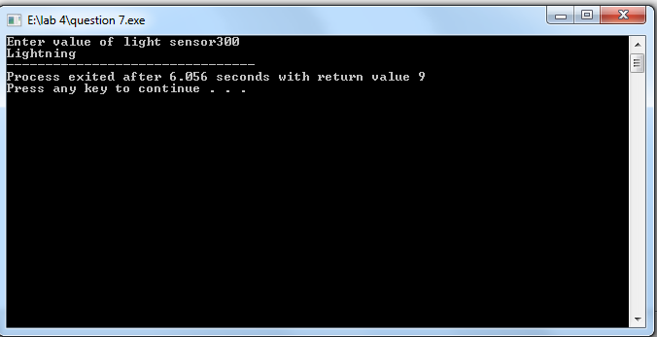

* **Question 8:**
* **Source code:**

#include <stdio.h>

int main()

{

int n;

printf("Enter the time in 24 hours format: ");

scanf("%d",&n);

if ((n>=5)&&(n<=11))

printf("Good Morning");

else if((n>=12)&&(n<=18))

printf("Good Evening");

else if((n>=19)&&(n<=24))

printf("Good Night");

}

* **Output:**

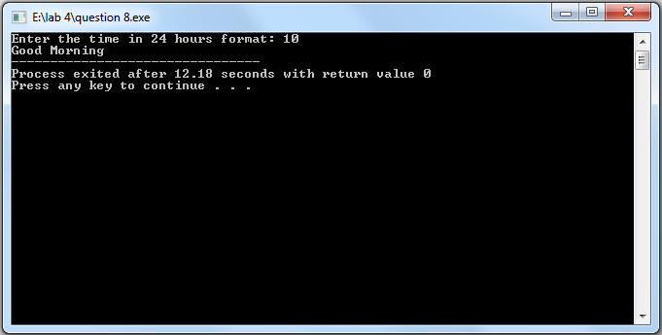

* **Question 9:**
* **Source code:**

#include <stdio.h>

Int main()

{

Int nts,fsc;

printf(“Enter marks of nts(50/60/70) and fsc(40-100): “);

scanf(“%d %d”, &nts, &fsc);

If ((fsc>=40)&&(fsc<=70))

{

printf(“You can enroll in MIT\n”);

If ((fsc>=40)&&(fsc<50)&&(nts==50))

printf(“You can enroll in Computer department”);

Else if ((fsc>=50)&&(fsc<60)&&(nts==50))

printf(“You can enroll in Chemical department”);

Else if ((fsc>=60)&&(fsc<=70)&&(nts==50))

printf(“You can enroll in IT department”);

}

Else if (fsc>70)

{

printf(“You can enroll in Oxford University\n”);

If (nts==50)

printf(“You can enroll in Telecommunication department”);

Else if(nts==60)

printf(“You can enroll in Electronics”);

Else if(nts==70)

printf(“You can enroll in IT");

}

}

* **Output:**

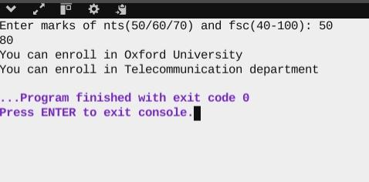

* **Question 10:**
* **Source code:**

#include <stdio.h>

int main()

{

float temp;

printf("Enter the value of temperature: ");

scanf("%f",&temp);

if (temp<0)

printf("Freezing weather");

else if((temp>=0)&&(temp<=10))

printf("Very cold weather");

else if((temp>=11)&&(temp<=20))

printf("Cold weather");

else if((temp>=21)&&(temp<=30))

printf("Normal temperature");

else if((temp>=31)&&(temp<=40))

printf("Hot weather");

else

printf("Very hot weather");

}

* **Output:**

